Outline
Test approach/ design 1
Report bugs 2
Defect 1: No message returns after user enter 2 digits code of Country 2
Defect 2: Searched weather result does not precisely when user enters the city name which is the same City Names in Different Countries 2
Defect 3: Using firefox browser, after searching multiple cities, the city label no longer render correctly 3
Defect 4: Dummy test data was tested in UAT environment 4
Defect 5: City ID in response body is 0 when user call API to search weather by zip code 5
Enhancement: Result returns more than one although user search weather of city as guideline 6

Test approach/ design
A heuristic is a rule-of-thumb, or a guide toward what behavior is appropriate for a certain situation. Heuristics are also known as “mental shortcuts”. For testing, we have some heuristic to apply when they are designing, creating tests, and performing. Then I choose SFDIPOT (San Francisco Depot) – Test Strategy Heuristics by James Bach for my testing approach and design.
The scope of this heuristic is applied to the product, however I could use some keywords from this heuristic to test the Search function in the Openweather page.

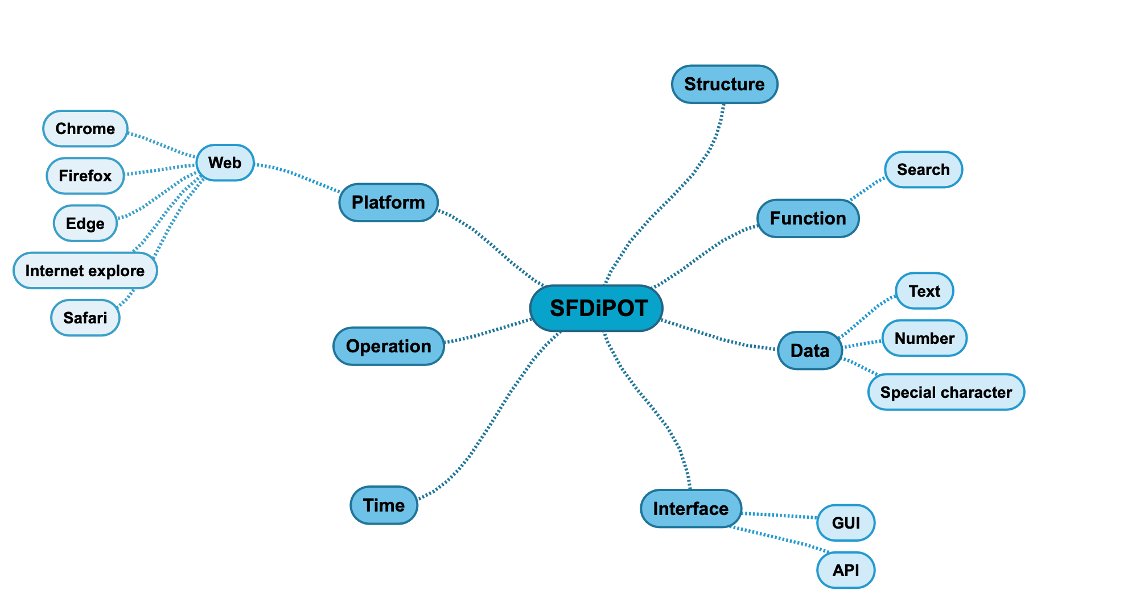
- Function: main function is search, so we have to ensure that it works properly on both cases: valid and invalid data.
  - Valid data (e.g: marid; seoul, kr)
  - Invalid data (vn, hanoi; hcm)
- Data: since the input method is entering to the text box, then we have 3 types of test data
  - Text (e.g: latin, non latin)
  - Number
  - Special character
  - Combine them all
- Interface: we are able to do search function via GUI and API, then we could approach test on
  - GUI
  - API
  - Combine GUI and API
- Flatform: This function is built in web base, we have some tools to access, so I will do the test on these browsers
  - Chrome
  - Firefox
  - IE
  - Edge
  - Safari
- Time (Performance test - manually): measure by Development tool on browser. Normally, the average of loading time is less than 5 seconds.
  - Landing on the home page
  - After hit to start searching
  - After click to go the city weather in details

Notes: For the design test case, please refer test scenarios in feature files for UI and API

Report bugs

Defect 1: No message returns after user enter 2 digits code of Country

Priority: Medium
Severity: Medium

Description:
The user enters 2 digits code of Country in the Search weather textbox and press Enter. I brought to the searched result page, however, no message returns

Test environment: https://openweathermap.org
Browsers: Chrome -Version 88, Firefox-Version 86

Step to reproduce:
- Navigate to Openweather page
- At the top of page, enter 2 characters of country code in search Weather textbox, e.g: vn, bv
- Observe the searched result

Actual result: No message returns.
Expected result: Message should display saying that “vn” is inappropriate, To make it more precise put the city's name, comma, 2-letter country code (ISO3166), e.g: Example - London, GB or New York, US.

Defect 2: Searched weather result does not precisely when user enters the city name which is the same City Names in Different Countries

Priority: High
Severity: Medium

Description:
There are some city with the same names in different countries, for example: Melbourne, Florida vs. Melbourne, Australia; Portland, Oregon (US) vs Portland, Maine(US) vs Portland, Victoria, (AU) vs Portland Square, Bristol (GB)

Test environment: https://openweathermap.org
Browsers: Chrome -Version 88, Firefox-Version 86

Step to reproduce:
1- Navigate to Openweather page
2- At the top of page, enter “Portland” in search Weather textbox
3- Observe the searched result

Actual result: Searched result does not contain Portland (GB)
Expected result: Searched result should be exact.

Defect 3: Using firefox browser, after searching multiple cities, the city label no longer render correctly

Priority: Critical
Severity: High

Description:
Using firefox browser and blocking the popup “Access your location”, the user searches the weather of some different cities, then the city label renders sometimes incorrectly.

Test environment: https://openweathermap.org
Browsers: Firefox-Version 86

Step to reproduce:
1- Navigate to Openweather page
2- Close popup “Access your location” or block this popup
3- At the top of page, enter “Texas” in search Weather textbox
4- Select any option in searched result, then city label is correct
5- At the top of page, enter “ho chi minh” in search Weather textbox
6- Select any option in searched result, then city label is correct
7- At the top of page, enter “rio” in search Weather textbox
8- Select any option in searched result
9- Observe the city label in result page

Actual result: City ID from URL is correct, but the city label no longer correct
Expected result: The result page should render data correctly.

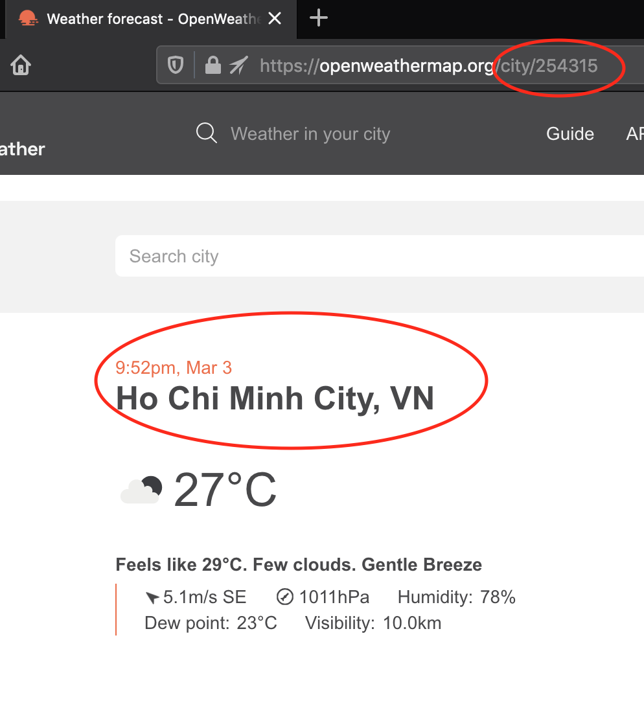

Defect 4: Dummy test data was tested in UAT environment

Priority: Critical
Severity: High

Description:
The user search weather with “testing” then the result returns

Test environment: https://openweathermap.org
Browsers: Chrome -Version 88, Firefox-Version 86

Step to reproduce:
1- Navigate to Openweather page
2- At the top of page, enter “testing” in search Weather textbox
3- Observe the searched result

Actual result: Dummy test data displays in result page
Expected result: Dummy test data should not be added to UAT environment

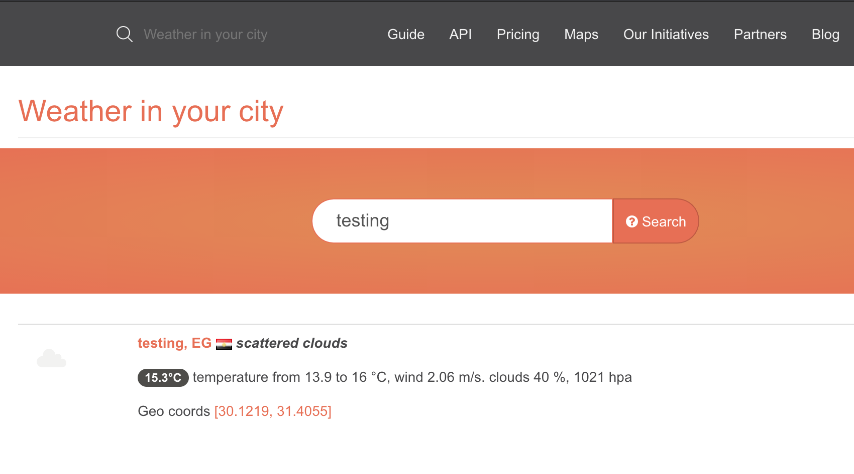

Defect 5: City ID in response body is 0 when user call API to search weather by zip code

Description:
In the API document for search weather by Zip code, ID in the response body is presented as a City ID. Actually, ID in response body is 0

Step to reproduce:
1- Calling API to search weather by zip code “10700,th”
2- Observe the ID in response body after calling successfully

Actual result: ID is 0
Expected result: ID should map to City ID, e.g 1619460

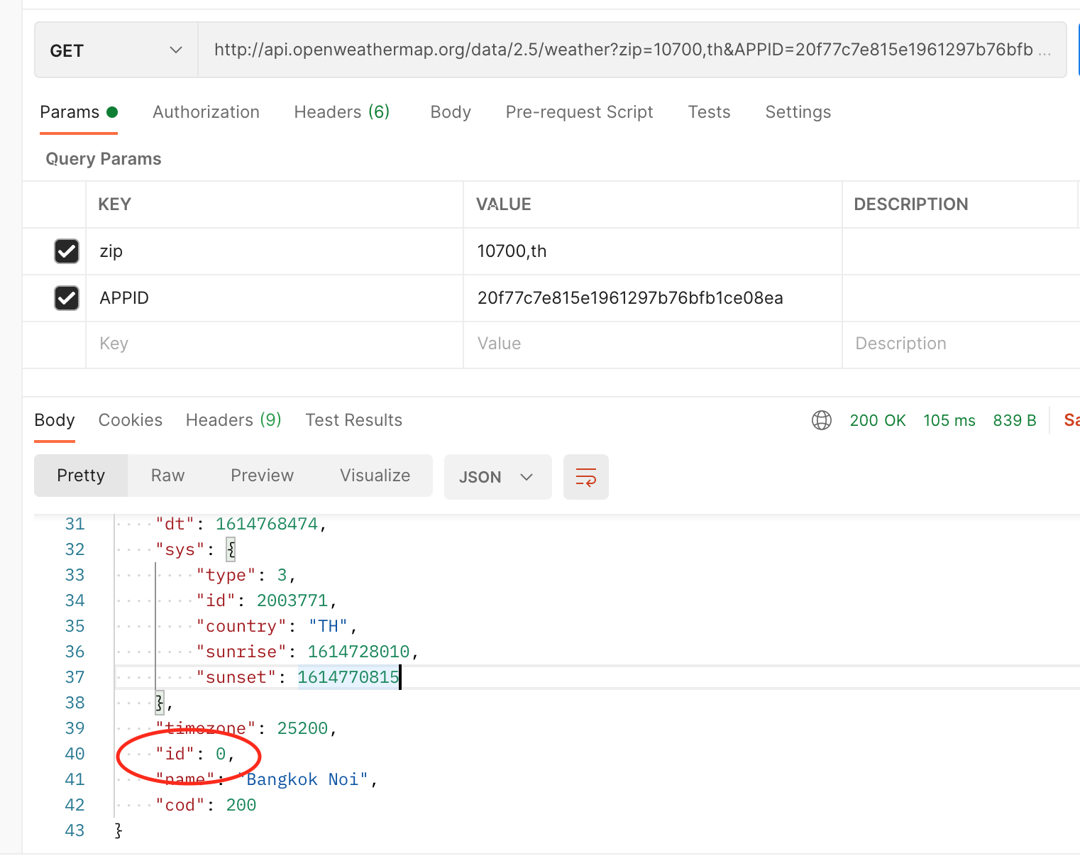

Enhancement: Result returns more than one although user search weather of city as guideline

Description:
Despite searching as a guideline, the result returned makes the user confused when there is more than one weather for the searched city.

Test environment: https://openweathermap.org
Browsers: Chrome -Version 88, Firefox-Version 86

Step to reproduce:
1- Navigate to Openweather page
2- At the top of page, enter “bangkok, th” in search Weather textbox
3- Observe the searched result

Actual result: Searched result returns more than one weather forecast
Expected result: Searched result returns only one forecast.

